Week 1: a. Create a Web Page using HTML which contains a Heading, Image and 2 hyperlinks. Each hyperlink opens a new page in the same web browser. New page contains “Go Back” link that takes you to the main page.

<!DOCTYPE html>

<html lang="en">

<head>

<meta charset="UTF-8">

<meta name="viewport" content="width=device-width, initial-scale=1.0">

<title>Main Page</title>

<style>

body {

font-family: Arial, sans-serif;

margin: 0;

padding: 0;

background-color: #f4f4f4;

}

.header-container {

display: flex;

align-items: center;

background-color: #4CAF50; /* Background color */

padding: 10px;

color: white;

}

.header-container img {

max-height: 50px; /* Adjust height as needed */

width: auto;

margin-right: 20px; /* Space between the image and heading */

}

.header-container h1 {

margin: 0;

flex: 1;

text-align: center; /* Center the heading */

}

a {

display: block;

margin: 10px 0;

color: #0066cc;

text-decoration: none;

}

a:hover {

text-decoration: underline;

}

</style>

</head>

<body>

<div class="header-container">

<img src="img-week1a.png " alt="Example Icon">

<h1>Welcome to the Main Page</h1>

</div>

<a href="page1.html">Go to Page 1</a>

<a href="page2.html">Go to Page 2</a>

</body>

</html>

**Page1.html**

<!DOCTYPE html>

<html lang="en">

<head>

<meta charset="UTF-8">

<meta name="viewport" content="width=device-width, initial-scale=1.0">

<title>Page 1</title>

<style>

body {

font-family: Arial, sans-serif;

margin: 0;

padding: 0;

background-color: #f4f4f4;

}

.header-container {

display: flex;

align-items: center;

background-color: #4CAF50; /* Background color */

padding: 10px;

color: white;

}

.header-container img {

max-height: 50px; /* Adjust height as needed */

width: auto;

margin-right: 20px; /* Space between the image and heading */

}

.header-container h1 {

margin: 0;

flex: 1;

text-align: center; /* Center the heading */

}

a {

display: block;

margin: 10px 0;

color: #0066cc;

text-decoration: none;

}

a:hover {

text-decoration: underline;

}

</style>

</head>

<body>

<div class="header-container">

<img src="img-page1.png " alt="Example Icon">

<h1>This is Page 1</h1>

</div>

<a href="index.html">Go Back</a>

</body>

</html>

**Page2.html**

<!DOCTYPE html>

<html lang="en">

<head>

<meta charset="UTF-8">

<meta name="viewport" content="width=device-width, initial-scale=1.0">

<title>Page 2</title>

<style>

body {

font-family: Arial, sans-serif;

margin: 0;

padding: 0;

background-color: #f4f4f4;

}

.header-container {

display: flex;

align-items: center;

background-color: #4CAF50; /* Background color */

padding: 10px;

color: white;

}

.header-container img {

max-height: 50px; /* Adjust height as needed */

width: auto;

margin-right: 20px; /* Space between the image and heading */

}

.header-container h1 {

margin: 0;

flex: 1;

text-align: center; /* Center the heading */

}

a {

display: block;

margin: 10px 0;

color: #0066cc;

text-decoration: none;

}

a:hover {

text-decoration: underline;

}

</style>

</head>

<body>

<div class="header-container">

<img src="img-page2.png " alt="Example Icon">

<h1>This is Page 2</h1>

</div>

<a href="index.html">Go Back</a>

</body>

</html>

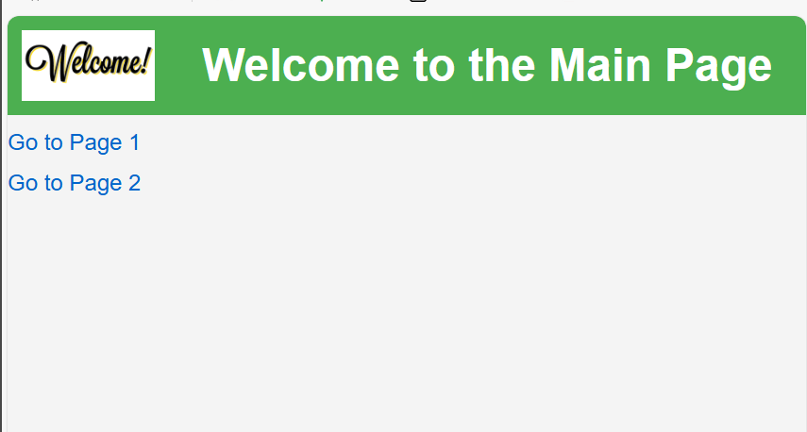**OUTPUT :**

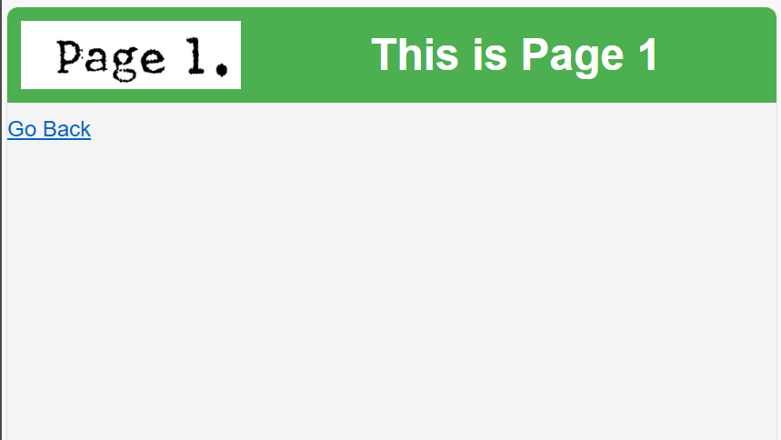

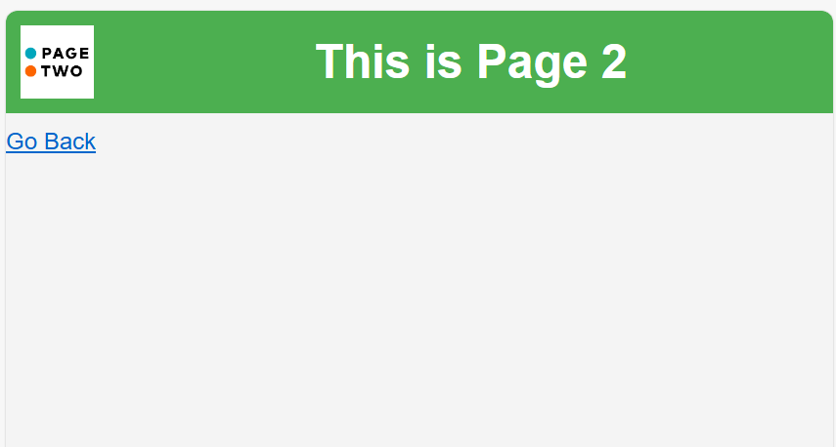

Week 1: b. Write a HTML program to create a Registration form, which contains User Name, Password, Date of Birth, Gender, Mail-id, Contact number, Address and Submit button.

<!DOCTYPE html>

<html lang="en">

<head>

<meta charset="UTF-8">

<meta name="viewport" content="width=device-width, initial-scale=1.0">

<title>Registration Form</title>

</head>

<body>

<h1>Registration Form</h1>

<form action="/submit-form" method="post">

<label for="username">Username:</label>

<input type="text" id="username" name="username" required><br><br>

<label for="password">Password:</label>

<input type="password" id="password" name="password" required><br><br>

<label for="dob">Date of Birth:</label>

<input type="date" id="dob" name="dob" required><br><br>

<label for="gender">Gender:</label>

<select id="gender" name="gender" required>

<option value="">Select Gender</option>

<option value="male">Male</option>

<option value="female">Female</option>

<option value="other">Other</option>

</select><br><br>

<label for="email">Email ID:</label>

<input type="email" id="email" name="email" required><br><br>

<label for="contact">Contact Number:</label>

<input type="tel" id="contact" name="contact" pattern="[0-9]{10}" required><br><br>

<label for="address">Address:</label><br>

<textarea id="address" name="address" rows="4" cols="50" required></textarea><br><br>

<button type="submit">Submit</button>

</form>

</body>

</html>

**OUTPUT :**

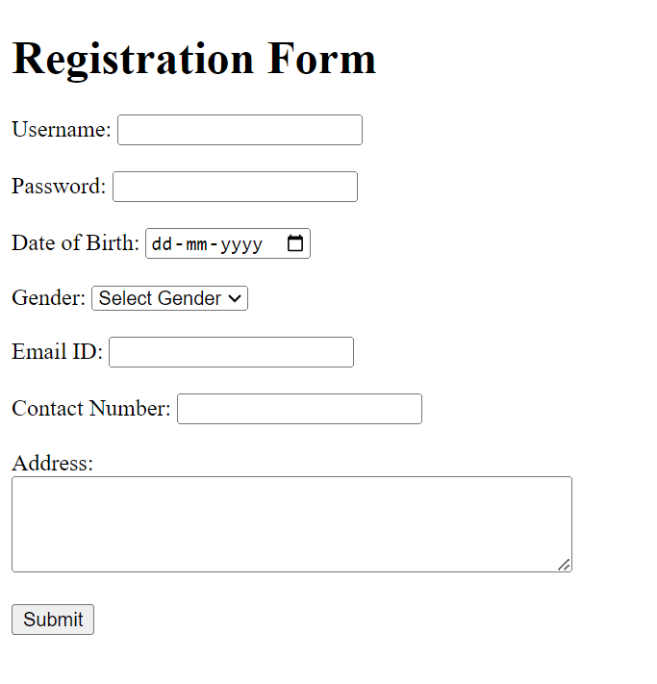

Week 2: a. Create a web page to demonstrate Position Property in CSS.

<!DOCTYPE html>

<html lang="en">

<head>

<meta charset="UTF-8">

<meta name="viewport" content="width=device-width, initial-scale=1.0">

<title>Position Property Demo</title>

<link rel="stylesheet" href="styles.css">

</head>

<body>

<header class="header">

<h1>Position Property Demo</h1>

</header>

<div class="content">

<div class="box static">

<p>Static Position</p>

</div>

<div class="box relative">

<p>Relative Position</p>

</div>

<div class="box absolute">

<p>Absolute Position</p>

</div>

<div class="box sticky">

<p>Sticky Position</p>

</div>

<div class="box fixed">

<p>Fixed Position</p>

</div>

<div class="box">

<p>More Content</p>

</div>

</div>

</body>

</html>

**Styles.css**

body {

margin: 0;

font-family: Arial, sans-serif;

line-height: 1.6;

}

.header {

background: hsl(62, 89%, 43%);

color: #fff;

text-align: center;

padding: 40px;

position: relative; /* Just for illustration; not required for sticky */

}

.content {

padding: 20px;

}

.box {

border: 2px solid #333;

padding: 20px;

margin-bottom: 20px;

background-color: #d87919;

text-align: center;

font-size: 1.2rem;

font-weight: bold;

color: #333;

}

.static {

position: static; /* Default position */

background-color: #65b074;

}

.relative {

position: relative;

top: 10px;

left: 10px;

background-color: #c4119d;

}

.absolute {

position: absolute;

top: 200px;

left: 20px;

background-color: hsl(270, 88%, 45%);

width: 120px;

}

.sticky {

position: sticky;

top: 0; /* Sticks to the top of the viewport */

background-color: hwb(296 7% 23%);

padding: 20px;

width: 100%;

z-index: 100; /* Ensures it stays above other content */

}

.fixed {

position: fixed;

bottom: 10px; /* Distance from the bottom of the viewport */

right: 10px; /* Distance from the right of the viewport */

background-color: hsl(211, 87%, 48%);

padding: 20px;

width: 130px;

z-index: 200; /* Ensures it stays above other content */

}

.box:last-child {

height: 1000px; /* Large height to allow scrolling */

background-color: #f1f1f1;

}

**OUTPUT :**

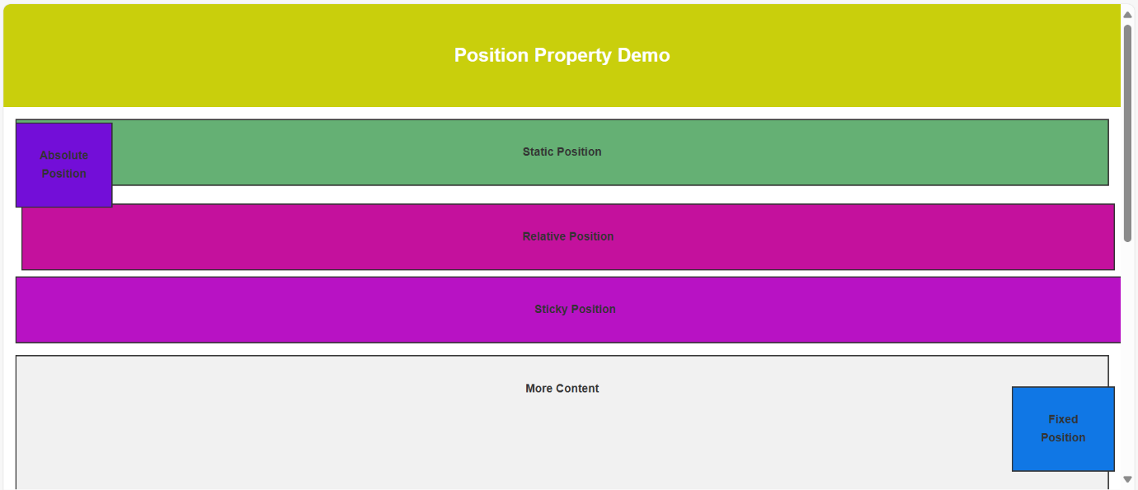

Week 2: b. Create a Newspaper Style Design to print minimum 2 articles using HTML and CSS.

<!DOCTYPE html>

<html lang="en">

<head>

    <meta charset="UTF-8">

    <meta name="viewport" content="width=device-width, initial-scale=1.0">

    <title>Newspaper Layout</title>

    <link rel="stylesheet" href="stlyess.css">

</head>

<body>

    <header class="header">

        <h1>Hindustan times</h1>

        <p class="date">August, 2024</p>

    </header>

    <main class="main-content">

        <section class="article">

            <img src="india+russia+img.jpg" alt="Article Image" class="article-image">

            <h2>India-Russia | Keeping an arms distance</h2>

            <p class="dropcap">India and Russia share decades of close strategic alliance. However, defence sales and military-technical cooperation—one of the pillars of the ‘special and privileged strategic partnership’—between the two nations have taken a backseat. In recent years, India has been reducing its reliance on Russian defence equipment and increasingly turning to western allies like the US and France as well as its domestic arms industry to meet its growing needs. This was evident during Prime Minister Narendra Modi’s two-day visit to Moscow on July 8 and 9 for the 22nd annual summit between the two nations. In the inaugural bilateral visit of his third term in office, PM Modi held both delegation-level talks and one-on-one discussions with President Vladimir Putin. On the back of bilateral trade reaching an all-time high of $65.70 billion (Rs 55,040 crores) in 2023-24—largely due to India buying large amounts of Russian oil—the focus was on economic aspects. Matters relating to energy, trade, manufacturing, technology and fertilisers were discussed. Announcement of a big defence deal was missing.</p>

        </section>

        <section class="article">

            <img src="olympics+img.png" alt="Article Image" class="article-image">

            <h2>India at the 2024 Summer Olympics</h2>

            <p class="dropcap"> India competed at the 2024 Summer Olympics in Paris, France, held from 26 July to 11 August 2024. The country made its debut at the 1900 Summer Olympics. Indian athletes have appeared at every edition of the Summer Olympic Games since 1920 and the Paris Games edition marked India's 26th appearance at the Summer Olympics

               The Indian contingent consisted of 110 athletes who competed in 16 sports. P.V. Sindhu and Sharath Kamal were the flag-bearers for the opening ceremony. Manu Bhaker and P. R. Sreejesh carried the Indian flag during the closing ceremony

                India won six medals including a silver and five bronze to be ranked 71st amongst the 206 NOCs that participated in the Olympics. This was India's third-best medal haul after the 2020 and 2012 respectively. Manu Bhaker won two bronze medals in shooting and became the first Indian to win two medals in a single Olympics since India gained independence. Neeraj Chopra, who won a silver medal in the men's javelin throw event, became the first Indian individual medalist to win a gold and silver at the Olympics. Wrestler Aman Sehrawat, who won a bronze medal became the youngest ever Indian medal winner in the Olympics..</p>

        </section>

    </main>

</body>

</html>

**Stlyess.css**

body {

    font-family: 'Georgia', serif,'italic';

    margin: 0;

    padding: 0;

    line-height: 1.6;

    color: #333;

}

.header {

    background-color: #f4f4f4;

    padding: 20px;

    text-align: center;

    border-bottom: 1px solid hsla(215, 91%, 41%, 0.999);

}

.header h1 {

    margin: 0;

    font-size: 3.5rem;

    font-family: 'Hindustan Times', cursive;

    background-color: hsl(212, 91%, 49%);

    padding: 60px;

}

.date {

    font-size: 1.1rem;

    color: #121111;

    background-color: #eee6ed;

}

.main-content {

    display: grid;

    grid-template-columns: 1fr 1fr;

    gap: 20px;

    padding: 20px;

    font-style: italic;

}

.main-content h2{

    text-decoration: underline;

}

.dropcap::first-letter{

    font-size:3em;

    float:left;

    margin-right: 5px;

    line-height: 1;

    font-weight: bold;

    color: #333;

}

.article {

    background-color: #ffffff;

    border: 1px solid #6e2929;

    border-radius: 5px;

    padding: 15px;

    box-shadow: 5 2px 4px rgba(0,0,0,0.1);

}

.article-image {

    width: 50%;

    height: auto;

    border-radius: 5px;

    margin-bottom: 15px;

}

.article h2 {

    font-size: 1.5rem;

    margin-top: 0;

}

.article p {

    margin: 0 0 10px;

    font-size: 1.0rem;

}

**OUTPUT :**

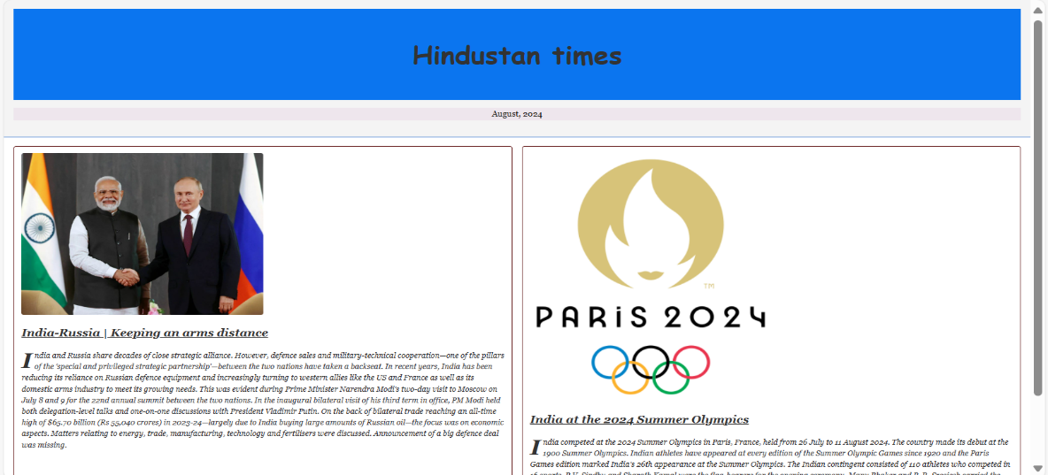

Week 3: a. Write a JavaScript program to change the background color after clicking “Change color” button.

<!DOCTYPE html>

<html>

    <head>

        <title>Change Colour</title>

        <style>

            body{

                margin: 150px;

                text-align: center;

                font-family: 'Times New Roman', Times, serif;

                font-size: 36px;

            }

            #sub{

                padding: 20px 30px;

                text-align: center;

                margin: 5px;

                font-size: 24px;

            }

        </style>

        <script>

            function changecolour(){

                const colors = ['#FF5733', '#33FF57', '#3357FF', '#FF33A6', '#A633FF', '#33FFF3'];

                const randcolour = colors[Math.floor(Math.random() * colors.length)];

                document.body.style.backgroundColor = randcolour;  // for multiple colours

                //document.body.style.backgroundColor = '#FF5733';   for single colour

            }

        </script>

    </head>

    <body>

        <h2>Click on the button to change the colours</h2>

        <button type="button" id="sub">Change color</button>

        <script>

            document.getElementById('sub').onclick = changecolour;

        </script>

    </body>

</html>

**OUTPUT :**

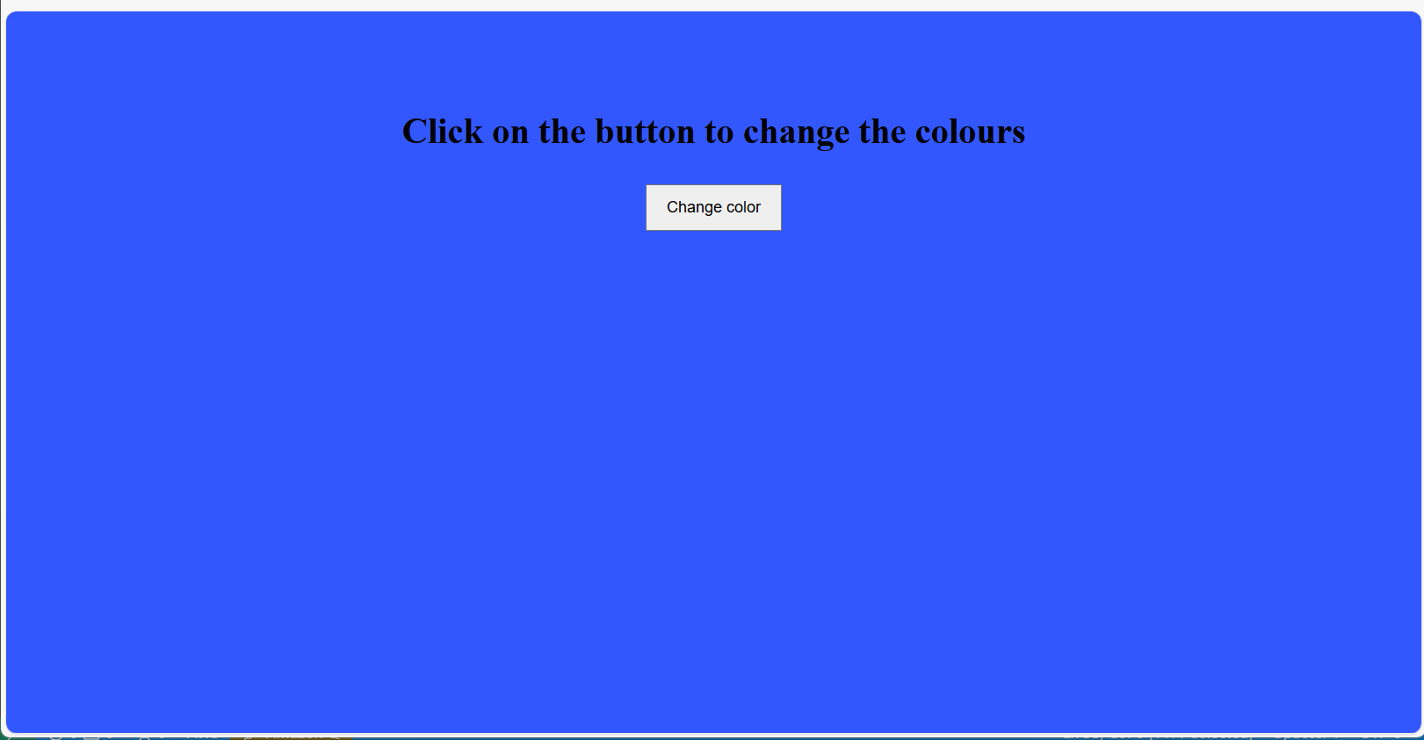

Week 3: b. Write a JavaScript program to validate registration page using regular expression.

<!DOCTYPE html>

<html lang="en">

<head>

    <meta charset="UTF-8">

    <meta name="viewport" content="width=device-width, initial-scale=1.0">

    <title>Registration Form</title>

    <script>

        function validate(){

            var usernamepat = /^[a-zA-Z][a-zA-Z0-9_]{5,15}$/;

            var passpat = /^(?=.*[a-z])(?=.*[A-Z])(?=.*\d)(?=.*[@$!%*?&])[A-Za-z\d@$!%*?&]{8,20}$/;

            var confirmpassid = /^(?=.*[a-z])(?=.*[A-Z])(?=.*\d)(?=.*[@$!%*?&])[A-Za-z\d@$!%*?&]{8,20}$/;

            var mailpat = /^[a-zA-Z0-9._-]+@[a-z0-9.-]+\.[a-z]{2,}$/;

            var conpat = /^[6-9][0-9]{9}$/;

            var unid = document.getElementById('username').value;

            if (!usernamepat.test(unid)) {

                alert("Enter a valid username.");

                document.getElementById('username').focus();

                return false;

            }

            var passid = document.getElementById('password').value;

            if (!passpat.test(passid)) {

                alert("Enter a valid password.");

                document.getElementById('password').focus();

                return false;

            }

            var confirmpassid = document.getElementById('confirmPassword').value;

            if (passid !== confirmpassid) {

                alert("Passwords do not match.");

                document.getElementById('confirmPassword').focus();

                return false;

            }

            var mailid = document.getElementById('email').value;

            if (!mailpat.test(mailid)) {

                alert("Enter a valid email address.");

                document.getElementById('email').focus();

                return false;

            }

            var telid = document.getElementById('contact').value;

            if (!conpat.test(telid)) {

                alert("Enter a valid contact number.");

                document.getElementById('contact').focus();

                return false;

            }

            return true;

        }

    </script>

</head>

<body>

    <form action="success.html" onsubmit="return validate()">

        <h1>Registration Form</h1>

        <label for="username">Username:</label>

        <input type="text" id="username" name="username" required><br><br>

        <label for="password">Password:</label>

        <input type="password" id="password" name="password" required><br><br>

        <label for="confirmPassword"><b>Confirm Password:</b></label>

        <input type="password" id="confirmPassword" name="confirmPassword" required><br><br>

        <label for="dob">Date of Birth:</label>

        <input type="date" id="dob" name="dob" required><br><br>

        <label for="gender"><b>Gender:</b></label><br>

        <input type="radio" name="gender" value="male" required>Male<br>

        <input type="radio" name="gender" value="female" required>Female<br><br>

        <label for="email">Email ID:</label>

        <input type="email" id="email" name="email" required><br><br>

        <label for="contact">Contact Number:</label>

        <input type="tel" id="contact" name="contact" required><br><br>

        <label for="address">Address:</label><br>

        <textarea id="address" name="address" rows="4" cols="50" required></textarea><br><br>

        <button type="submit">Submit</button>

    </form>

</body>

</html>

**Success.html**

<!DOCTYPE html>

<html>

    <body>

        <h2><center> Registration succesfull</center></h2>

        <p><center>Thank you for registering</center></p>

    </body>

</html>

**OUTPUT :**

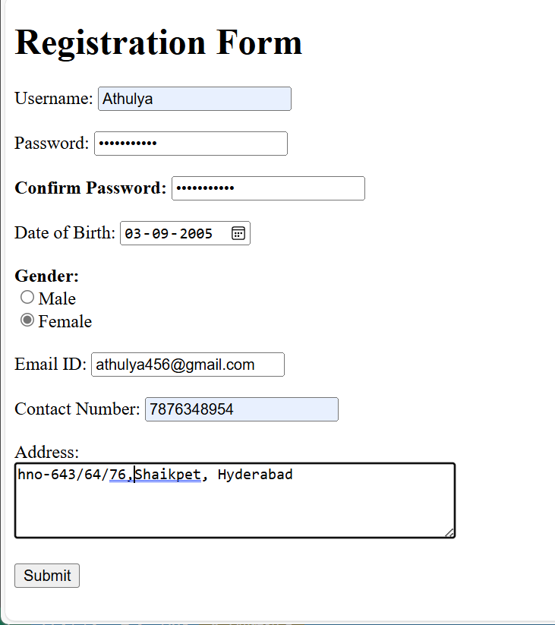

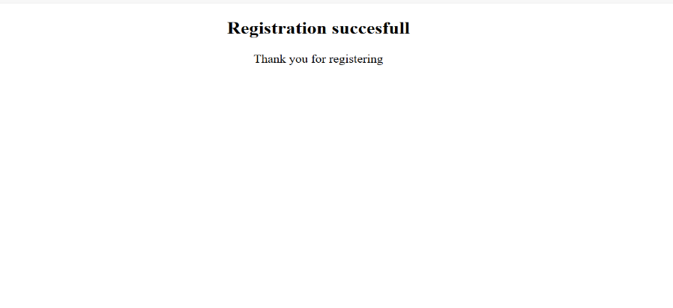

Week 4: a. Write a code to hide and show an element in a periodic interval without any action from the user using JQuery.

<!DOCTYPE html>

<html lang="en">

<head>

    <meta charset="UTF-8">

    <meta name="viewport" content="width=device-width, initial-scale=1.0">

    <title>Week 4(a).</title>

    <script src="https://code.jquery.com/jquery-3.7.1.min.js"></script>

    <script>

        function f(){

            $(document).ready(function(){

                $("p").fadeToggle(2000,f());

            })

        }

        $(document).ready(function(){

            f();

        })

        $(document).ready(function(){

            setInterval(function(){

                $("p").fadeToggle(1000)},

                3000);

        })

    </script>

</head>

<body>

    <p style="height: 130px; color:aquamarine;background-color:pink;font-size:xx-large;text-decoration:underline;">This is a paragraph that hides and show.</p>

</body>

</html>

**OUTPUT :**

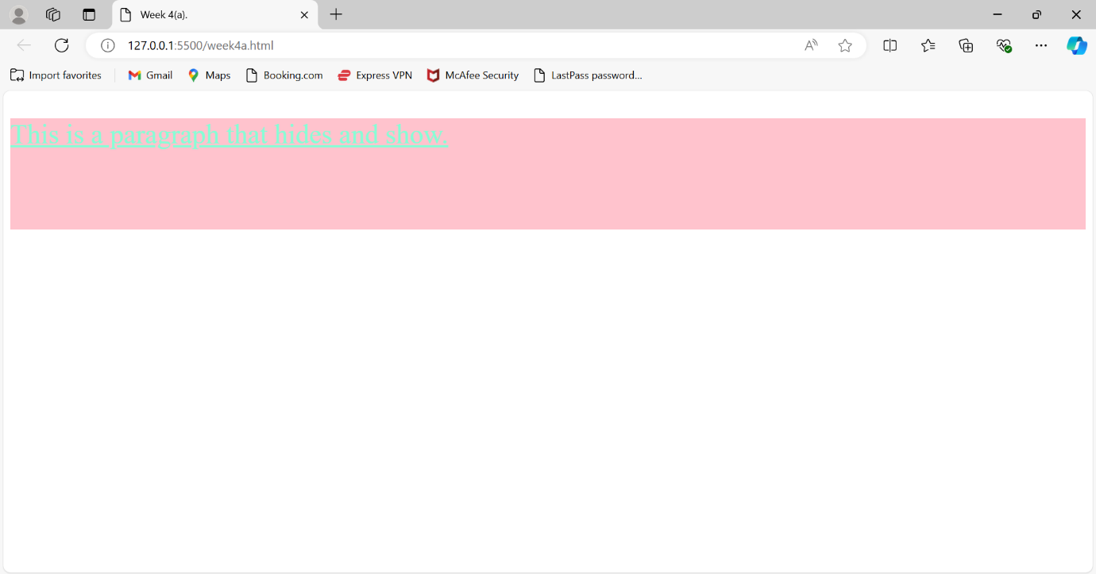

Week 4: b. Write a program to create and build a star rating system using JQuery.

<!DOCTYPE html>

<html lang="en">

<head>

    <meta charset="UTF-8">

    <meta name="viewport" content="width=device-width, initial-scale=1.0">

    <title>5 Star Rating.</title>

    <script src="https://code.jquery.com/jquery-3.7.1.min.js"></script>

    <style>

        .container{

            border:2px solid blueviolet;

            margin-border: 20px;

            padding: 10px;

        }

        p{

            margin: 0;

            padding:0;

        }

        .star-rating{

            font-size: 0;

            direction: rtl;

            display: inline-block;

        }

        .star-rating input{

            display: none;

        }

        .star-rating label{

            font-size: 2rem;

            padding: 0 0.1rem;

            cursor: pointer;

            color:gray;

        }

        .star-rating input:checked ~ label{

            color:yellow;

        }

        .star-rating label:hover,

        .star-rating label:hover ~ label{

            color: orange;

        }

    </style>

    <script>

        $(document).ready(function(){

            $(".star-rating input").click(function(){

                var rating=$(this).val();

                alert("You rated this "+rating+" stars.");

            })

        })

    </script>

</head>

<body>

    <h2>Rating System.</h2>

    <div class="container">

    <div class="star-rating">

        <input type="radio"name="rating"id="5-star"value="5">

        <label for="5-star">&#9733</label>

        <input type="radio"name="rating"id="4-star"value="4">

        <label for="4-star">&#9733</label>

        <input type="radio"name="rating"id="3-star"value="3">

        <label for="3-star">&#9733</label>

        <input type="radio"name="rating"id="2-star"value="2">

        <label for="2-star">&#9733</label>

        <input type="radio"name="rating"id="1-star"value="1">

        <label for="1-star">&#9733</label>

    </div>

    </div>

</body>

</html>

**OUTPUT :**

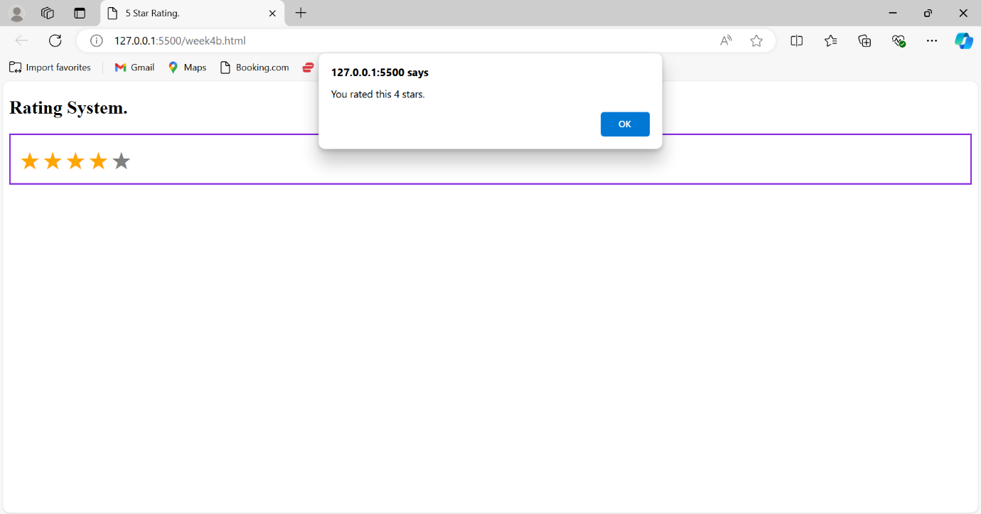

Week 5: a. Write a program to demonstrate ReactJS class and instance

**Index.js**

import React from 'react';

import ReactDOM from 'react-dom/client';

import App from'./App';

const rt=ReactDOM.createRoot(document.getElementById('root'));

rt.render(<App/>);

**App.js**

import React from 'react';

import ReactDOM from'react-dom/client';

class App extends React.Component{

render(){

const msg=(<><h1>Helloworld</h1</>);

return (msg);

}

}

export default App

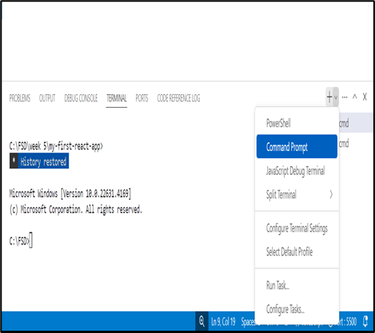**OUTPUT :**

